PROJECT DOCUMENTATION

Implement Client Script & UI Policy (Incident)

Project Title |  | Implement Client Script & UI Policy (Incident)
Technology / Platform |  | ServiceNow
Project Type |  | ServiceNow Incident Management / Client-side Automation
Student Name |  | S.Swetha, M.Yogadarshini, S.Harini, A.Thameem Nisha, M.Marshitha
Institution / Department |  | St.Joseph’s Arts and Science College for Women
Programme/Year |  | B.SC Computer Science-3rd Year
Submission Date | 25.09.2026

1. Project Overview
Incident records require consistent and accurate data entry for effective triage, routing, and resolution. Relying only on manual checks can result in incomplete, inconsistent, or incorrect data. This project demonstrates how ServiceNow UI Policies and Client Scripts can enforce conditional field behavior and validation directly on the Incident form.
1.1 Problem Statement
Manual data entry can lead to incomplete or incorrect Incident records, affecting reporting accuracy, SLA compliance, and service quality. The project addresses this by applying standardized UI behavior and save-time validation.
1.2 Project Objectives
- Enforce data integrity on Incident records.
- Make fields mandatory under defined conditions.
- Auto-populate values when Impact changes.
- Control field behavior such as read-only status.
- Prevent record submission when required conditions are not met.
- Validate the completed configuration through test scenarios.
1.3 High-Level Workflow
Incident Form → Impact = High → UI Policy / Client Scripts → Mandatory & Read-only behavior → Automatic Urgency update → Save validation → Incident record.

2. Skills / Concepts Used
- Incident Management
- UI Policy
- UI Policy Actions
- Client Scripts
- Form Validation
2.1 Configuration Requirements
- ServiceNow instance with administrative or configuration access.
- Incident table and Incident form.
- Access to System UI → UI Policies.
- Access to System UI → Client Scripts.
- Ability to create and test Incident records.
2.2 Business Rules Implemented
- When Impact is High, Assignment group is made mandatory through the UI Policy action.
- When Impact is High, Urgency becomes read-only.
- When Impact changes to High, Urgency is automatically set to High.
- When Impact is High and Assigned To is empty, saving is prevented.
- Direct State changes through list editing are blocked.
- State changes through the Incident form are allowed.

3. Task 1 – Create UI Policy on Incident
3.1 Activity: Create UI Policy
- Log in to the ServiceNow instance with administrative or configuration access.
- Navigate to System UI → UI Policies.
- Click New.
- Name: High Impact Control.
- Table: Incident.
- Active: true.
- Condition: Impact is 1 – High.
- Configure the UI Policy Action for Assignment group and check Mandatory.
- Set Reverse if false to true.
- Review the configuration and click Submit.

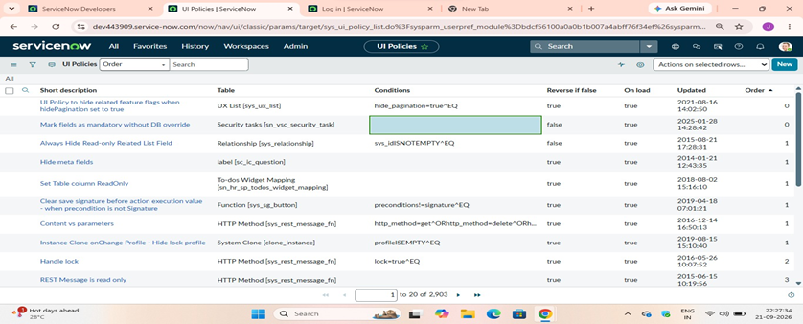

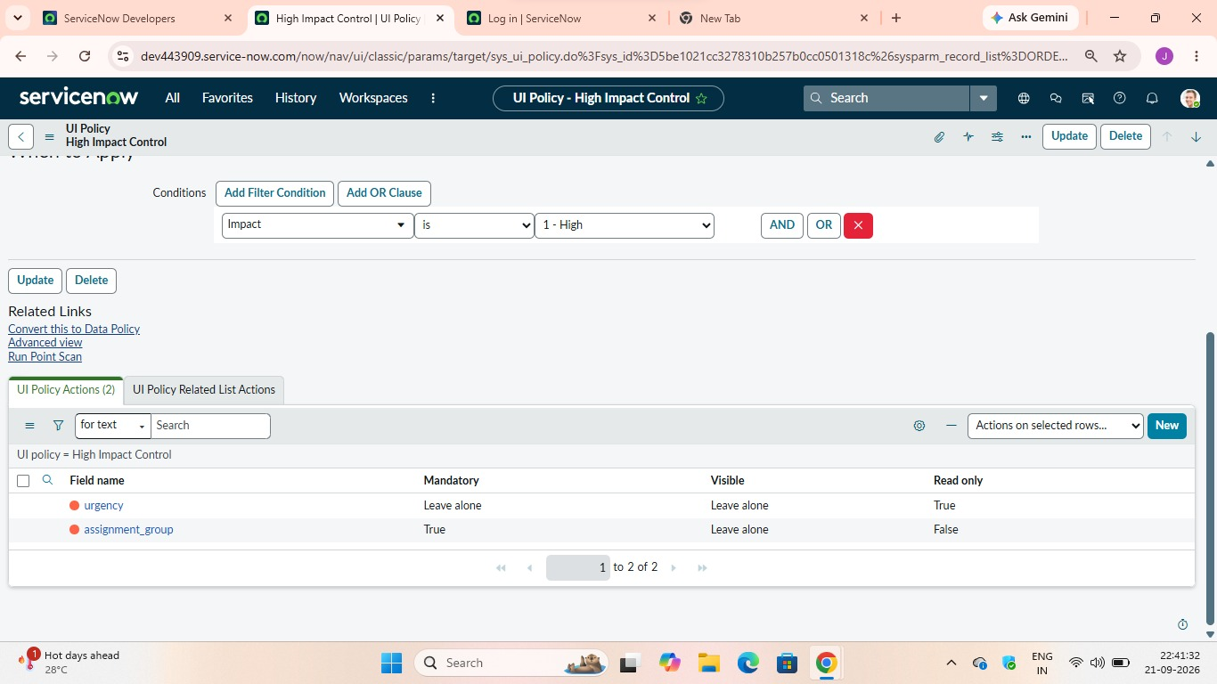
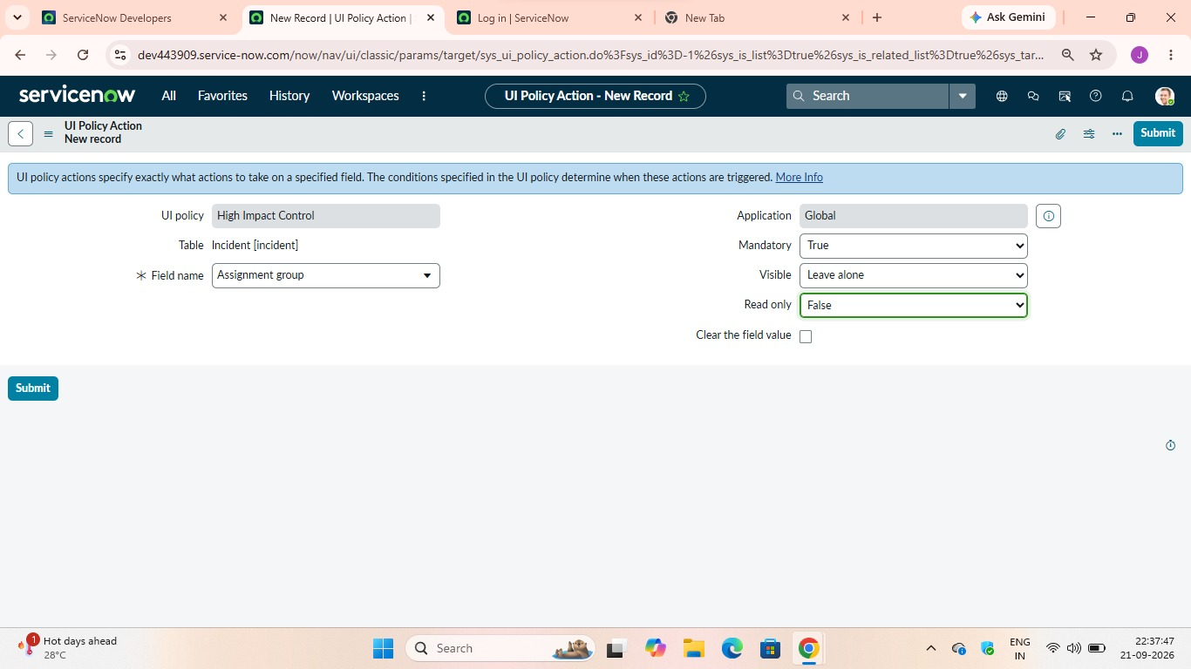

4. Task 2 – Create UI Policy Action – Urgency
4.1 Activity: Configure the Urgency Field
- Open the High Impact Control UI Policy.
- Go to the UI Policy Actions related list.
- Click New.
- Field name: Urgency.
- Read-only: true.
- Visible: Leave unchanged.
- Click Submit.
Verification: Set Impact to High on an Incident and confirm that Urgency becomes read-only. Change Impact to another value
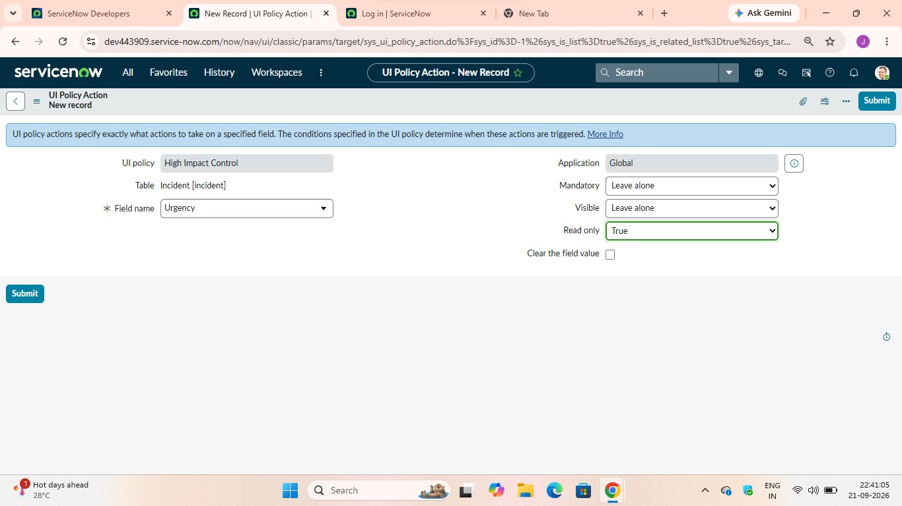
5. Task 3 – Create onChange Client Script
5.1 Activity: Create Client Script
- Navigate to System UI → Client Scripts.
- Click New.
- Name: Auto set urgency for high impact.
- Table: Incident.
- Type: onChange.
- Field name: Impact.
- Active: true.
- Paste the script and click Submit.
5.2 Script
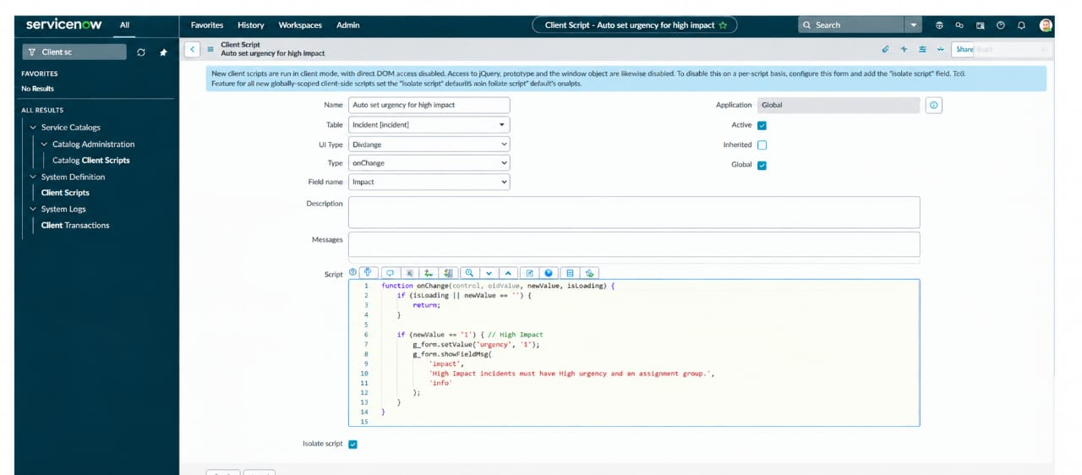
function onChange(control, oldValue, newValue, isLoading) {
if (isLoading || newValue == '') {
return;
}
if (newValue == '1') {
g_form.setValue('urgency', '1');
g_form.addInfoMessage('Urgency set to High for High impact incident.');
}
}

6. Task 4 – Create onSubmit Client Script (Save Validation)
6.1 Activity: Create Client Script
- Navigate to System UI → Client Scripts.
- Click New.
- Name: Prevent save if Assigned To missing.
- Table: Incident.
- Type: onSubmit.
- Active: true.
- The script checks whether Assigned To is empty when Impact is High and prevents saving.
- Click Submit.
6.2 Script
function onSubmit() {
if (g_form.getValue('impact') == '1' &&
g_form.getValue('assigned_to') == '') {
g_form.showErrorBox(
'assigned_to',
'Assigned To is mandatory for High impact incidents.'
);
return false;
}
return true;
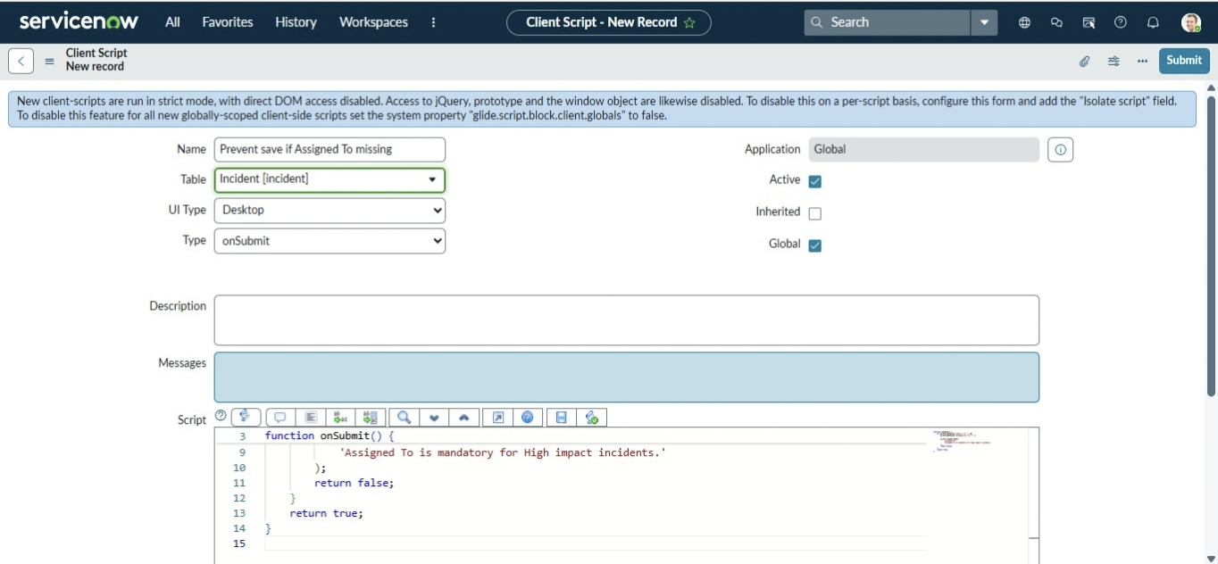
}

7. Task 5 – Create onCellEdit Client Script
7.1 Activity: Create Client Script
- Navigate to System UI → Client Scripts.
- Click New.
- Name: Prevent state change via list edit.
- Table: Incident.
- Type: onCellEdit.
- Field name: State.
- Active: true.
- The script prevents unauthorized changes to State through list editing.
- Click Submit.
7.2 Script
function onCellEdit(sysIDs, table, oldValues, newValue, callback) {
alert('State cannot be updated using list editing. Please open the Incident.');
callback(false);
}

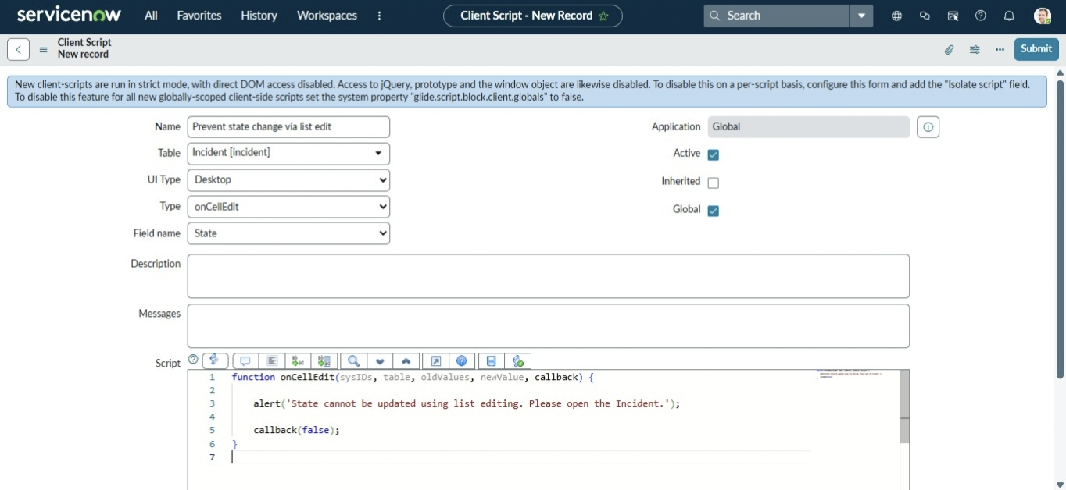
8. Task 6 – Testing the Configuration
8.1 Test Mandatory Enforcement
- Go to Incident → Create New.
- Set Impact to High.
- Leave Assigned To empty.
- Click Submit.
- Expected result: the Incident should not be saved.
- An error message should indicate that Assigned To cannot be empty.
- Confirm UI Policy actions and automatic urgency update.

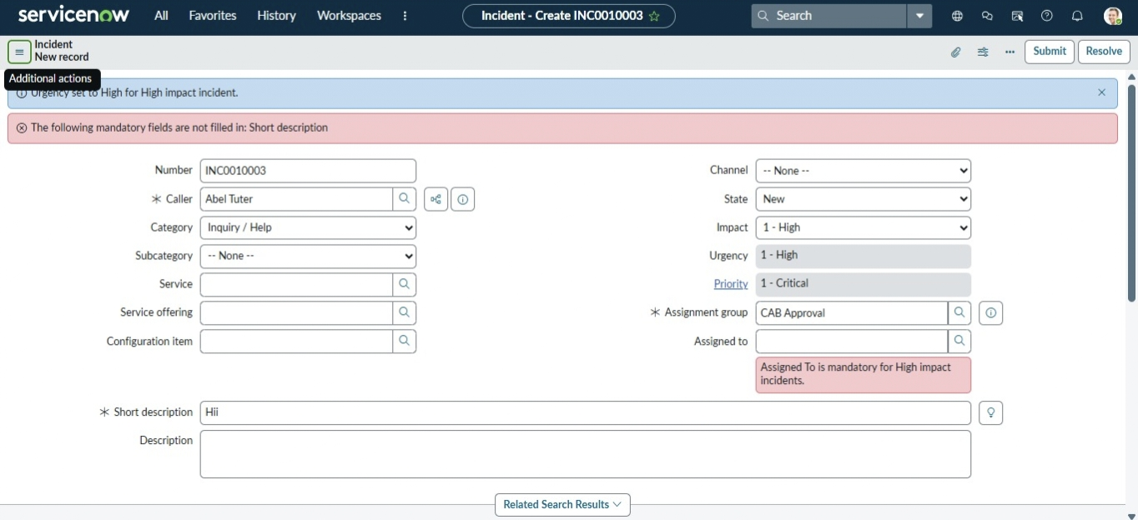

8.2 Test Successful Save
- Select a user in Assigned To.
- Click Submit.
- Expected result: the Incident should save successfully.
- Confirm urgency auto-setting, read-only behavior, and State restrictions.

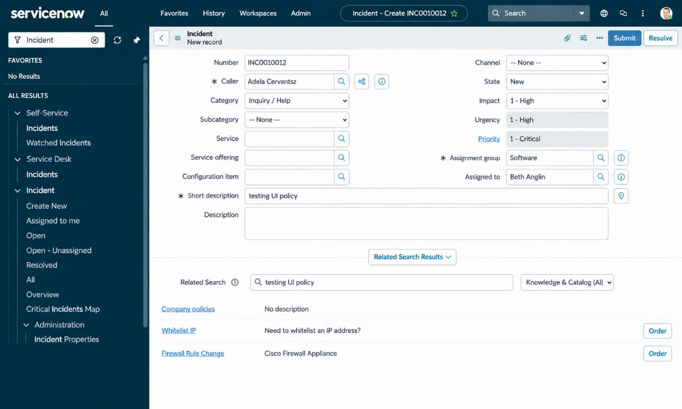
9. Additional Testing
9.1 Reverse Condition Test
- Open an existing Incident where Impact is High.
- Change Impact from High to Medium.
- Assigned To should no longer be mandatory.
- Urgency should become editable because the read-only UI Policy action is reversed.
- Save the record and confirm successful update.

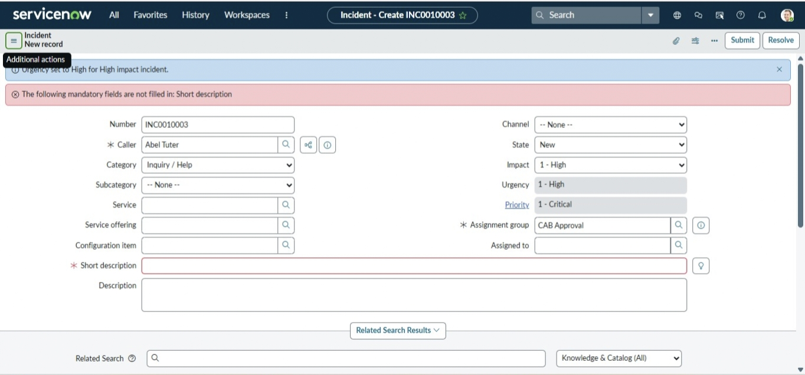

9.2 Test List Edit Blocking
- Go to Incident → All.
- Double-click the State field.
- Expected result: an alert states that direct State changes are not allowed.
- The State value remains unchanged.
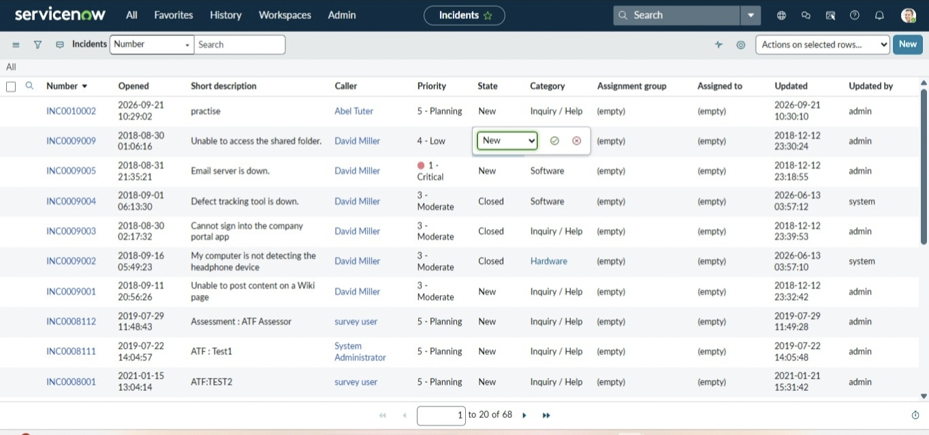

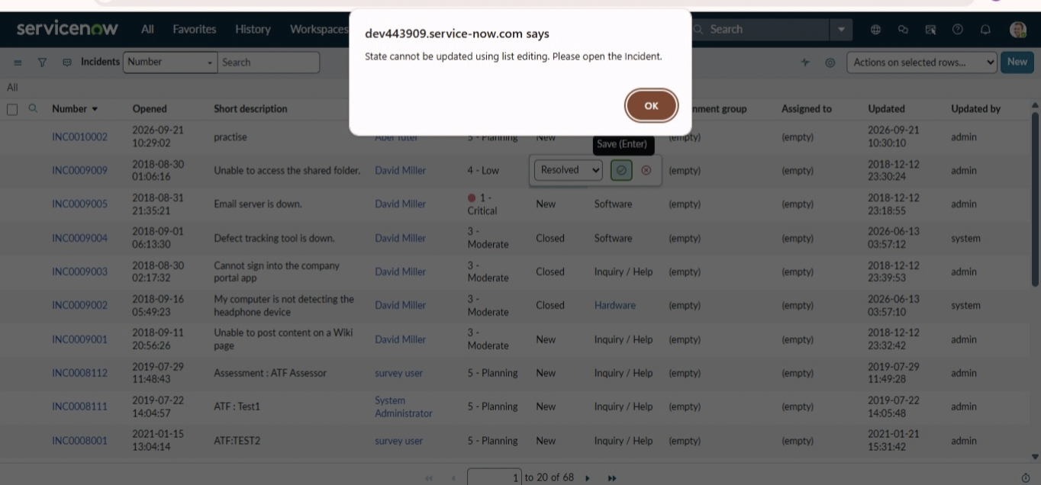
10. Form-Based Update & Test Summary
10.1 Test Form-Based Update
- Open the Incident record.
- Change the State field on the Incident form.
- Click Update.
- Expected result: the State change is saved successfully.
- Confirm that Assigned To and Urgency still follow the configured rules.

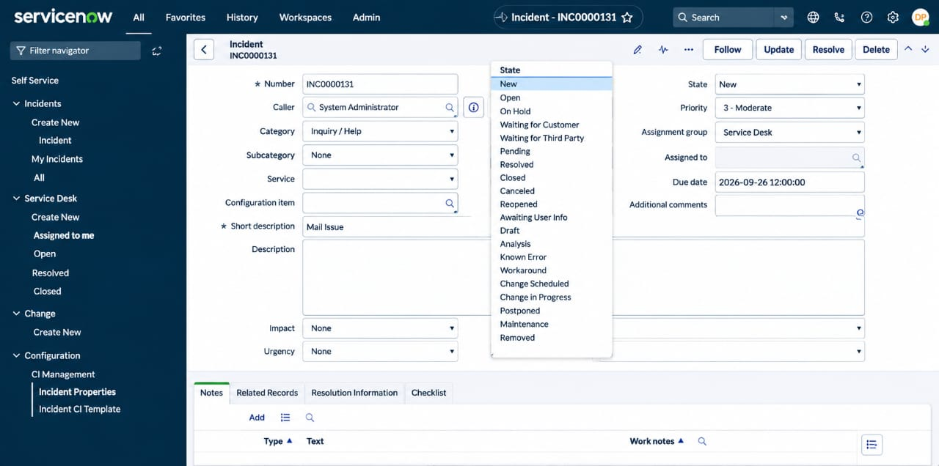

10.2 Test Case Summary

Test Case | Condition / Action | Expected Result | Status
TC-01 | Impact = High; Assigned To empty; Submit | Save blocked with validation message | PASS / after testing
TC-02 | Impact = High | Urgency set to High and read-only | PASS / after testing
TC-03 | Impact changed to Medium | Assigned To not mandatory; Urgency editable | PASS / after testing
TC-04 | Edit State from list | Alert shown; State unchanged | PASS / after testing
TC-05 | Edit State from form | State update saved | PASS / after testing

11. Expected Results
- High Impact incidents trigger the configured UI Policy.
- Assignment group becomes mandatory under the configured condition.
- Urgency becomes read-only when Impact is High.
- Urgency is automatically set to High when Impact changes to High.
- An Incident cannot be saved with High Impact when Assigned To is empty.
- Direct State changes through list editing are blocked.
- State changes through the Incident form are allowed.
- Changing Impact away from High reverses the applicable UI Policy behavior.

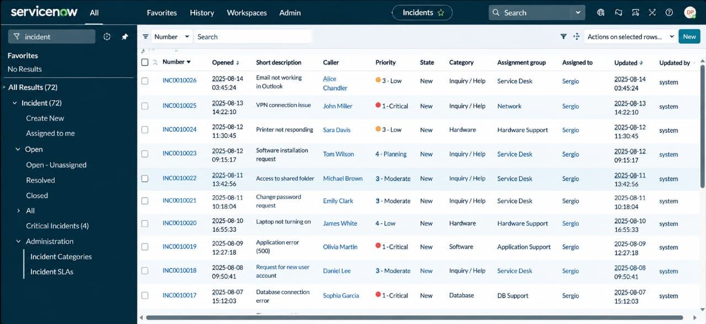

12. Project Summary
- Platform: ServiceNow.
- Module: Incident Management.
- UI Policy: High Impact Control.
- Client Scripts: onChange, onSubmit, and onCellEdit.
- Main controlled fields: Impact, Assignment group, Urgency, Assigned To, and State.
- Validation and testing are included as part of the implementation.
13. Future Enhancement Ideas
- Extend validation rules for additional Incident fields.
- Add more conditional UI behavior for different Impact or Priority combinations.
- Add further user guidance and validation messages where required.
- Expand test coverage for additional Incident scenarios.

14. Conclusion

The Implement Client Script & UI Policy (Incident) micro project demonstrates how UI Policies and Client Scripts can work together to enforce dynamic field behavior, automate updates, and prevent incorrect data submission on Incident forms. By using onChange, onSubmit, and onCellEdit scripts alongside UI Policy actions, the project ensures that fields such as Assigned To and Urgency respond appropriately to changes in Impact, maintaining clean and consistent data. The solution is lightweight, efficient, and suitable for a short-duration micro project while demonstrating practical approaches for improving form usability and data integrity in ServiceNow

